# Digital Marketing Website — Design, Pages & Modules

Date: September 17, 2025

## 1. Introduction

This document explains the essential pages (modules) of a modern digital marketing website, describes what each page should contain visually and functionally, and provides mockup screenshots and source links you can use as inspiration. The document deliberately avoids code and focuses on design, content, and functionality so you can present the site structure and ideas to stakeholders.

## 2. Essential Pages (At a Glance)

### Homepage

First impression. Summarize services, highlight results, capture leads with CTAs.

### Services

Detail the services offered (SEO, PPC, Social Media, Content Marketing, Analytics).

### Case Studies / Portfolio

Show real results: problem → solution → metrics. Builds trust.

### About

Agency story, team, mission, values, awards.

### Contact

Lead capture form, contact info, map, and strong CTAs.

### Testimonials

Social proof: client quotes, photos, logos.

## 3. Page-by-Page Details (with mockup images)

### Homepage

Purpose:  
- Create an immediate emotional and professional impression.  
- Communicate your value proposition in one glance.  
- Guide visitors to take action (Contact, Book a Call, Download Resource).  
  
Key Visual Elements:  
- Large hero with headline + subheadline + primary CTA.  
- Brief services summary (3–6 cards).  
- Client logos/trust badges.  
- Featured case study/portfolio preview.  
- Testimonials and a footer with quick contact.



**Source: https://www.smartsites.com/**

### Services Section

Purpose:  
- Explain the services you offer clearly and concisely.  
  
Key Visual Elements:  
- Service cards with icon/image, short benefit-driven description, and CTA.  
- Option to link to dedicated service detail pages.

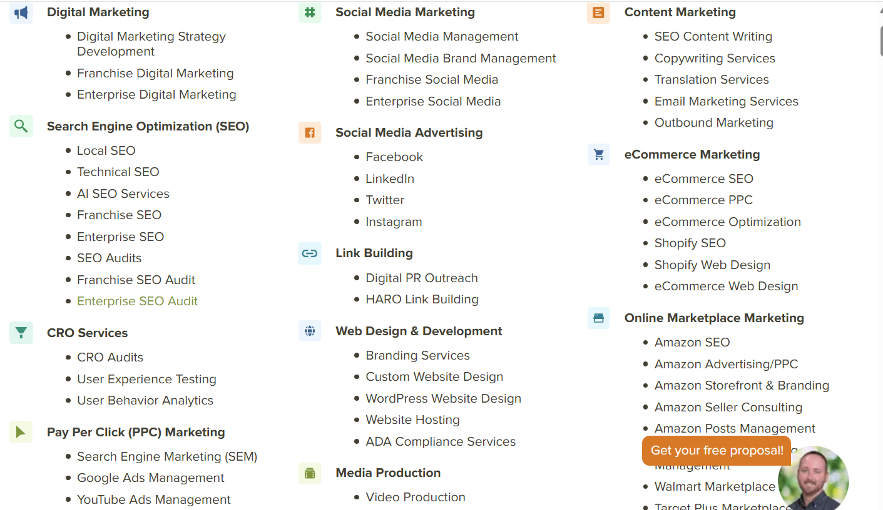

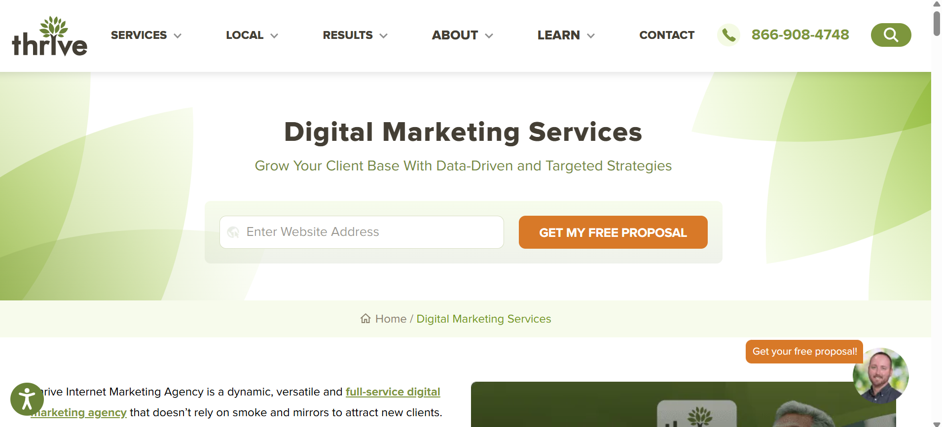

**Source: https://thriveagency.com/digital-marketing-services/**

### Case Studies

Purpose:  
- Showcase real client success stories  
  
Key Visual Elements:  
- Project thumbnail or client logo for recognition  
- Clear structure: *Challenge → Solution → Results.*  
- Metrics or KPIs highlighted (e.g., traffic %, leads, ROI).

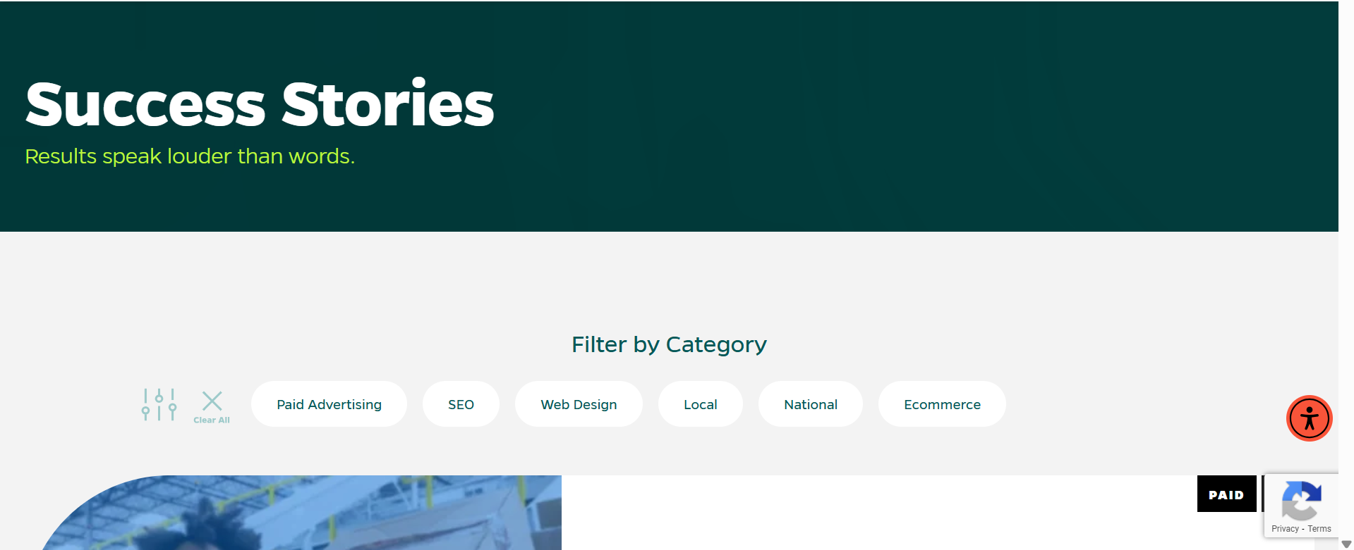

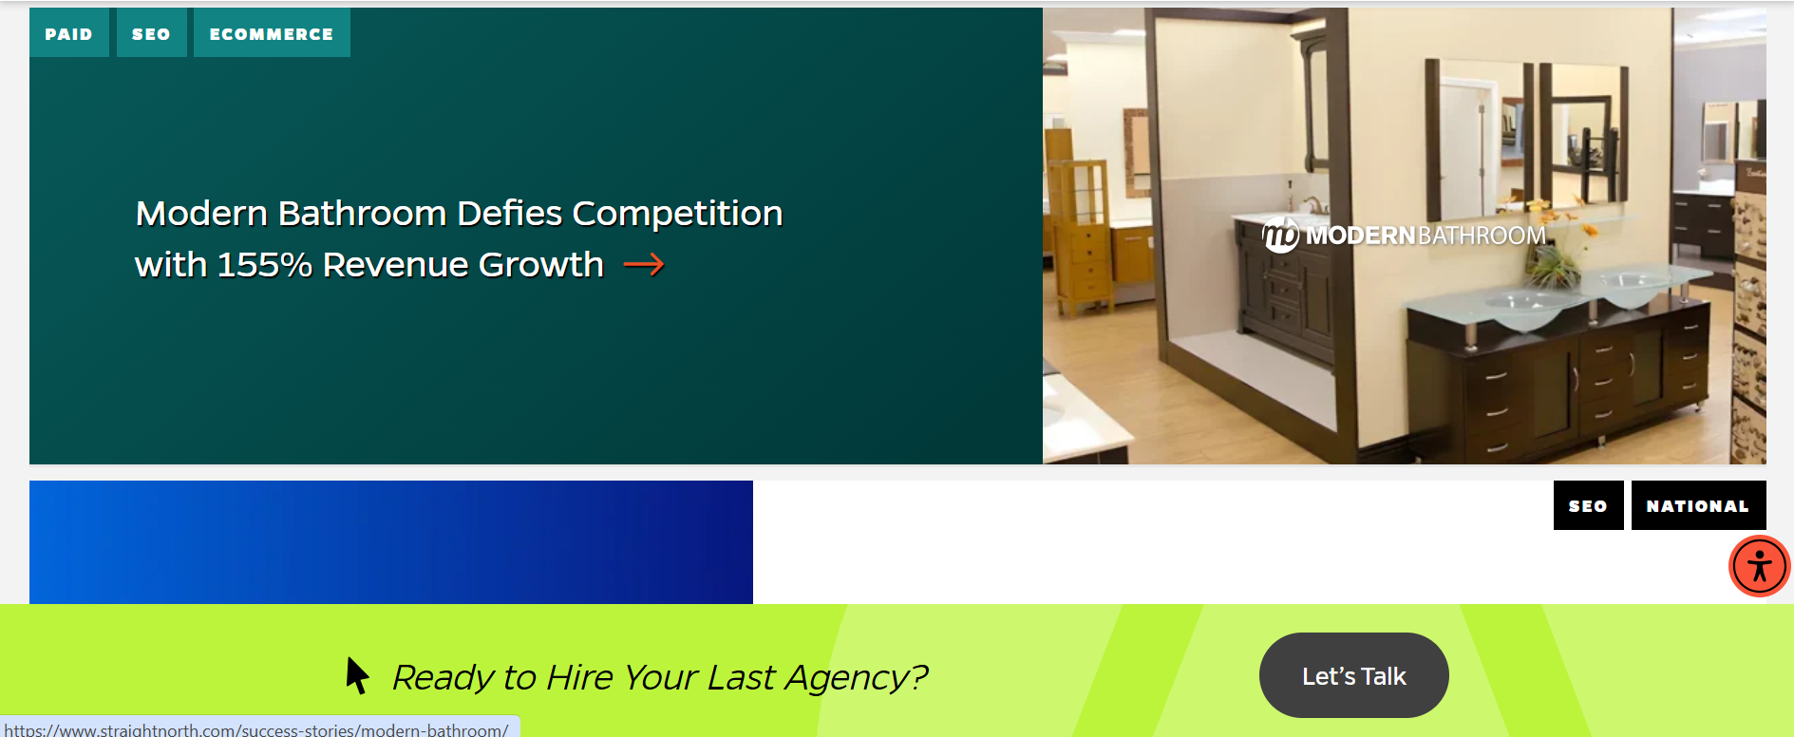

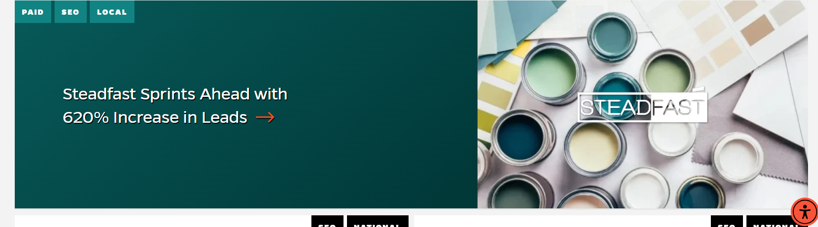

**Source: https://www.straightnorth.com/success-stories/**

### Contact Page

Purpose:  
- Capture leads through a form and provide contact details.  
  
Key Visual Elements:  
- Simple contact form (Name, Email, Phone, Message).  
- Map or office address, phone number, and email.  
- Clear privacy consent text for GDPR/consent if collecting data.

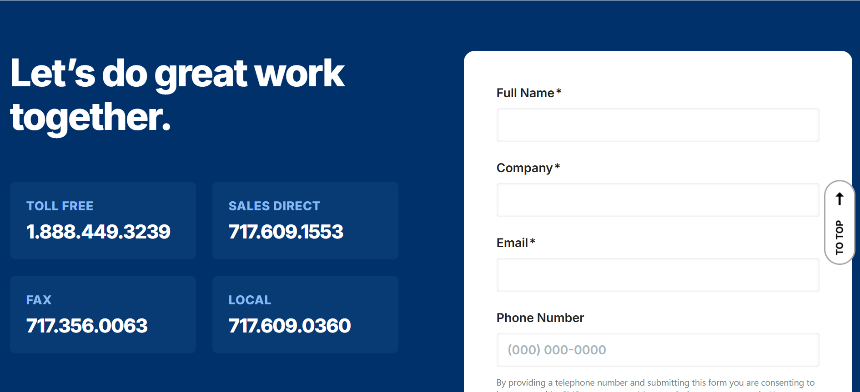

**Source:** [**https://www.webfx.com/contact/**](https://www.webfx.com/contact/)

## About / Team Page

Purpose:  
- Share the company mission, vision, and story to build credibility.  
- Introduce the team members with photos, names, and roles to humanize the brand.  
- Highlight awards, certifications, or milestones that make the agency stand out.  
  
Key Visual Elements:  
- Team section with grid of photos and short bios.  
- Company culture photos.

  
  
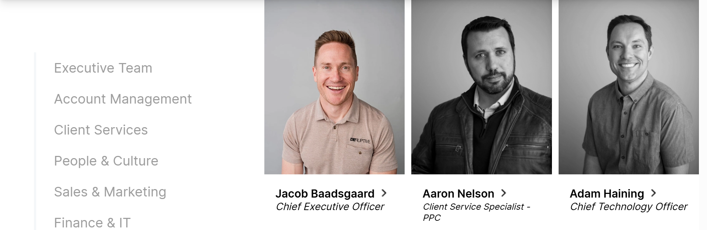

## Testimonials / Reviews Page

Purpose:  
- Provide social proof that builds trust with potential clients.  
- Demonstrate client satisfaction and results achieved.  
  
Key Visual Elements:  
- Short client quotes with names, roles, and company logos.  
- Star ratings or visual indicators of satisfaction.  
- Optional: Video testimonials for more impact.  
- Carousel or grid layout for easy browsing.

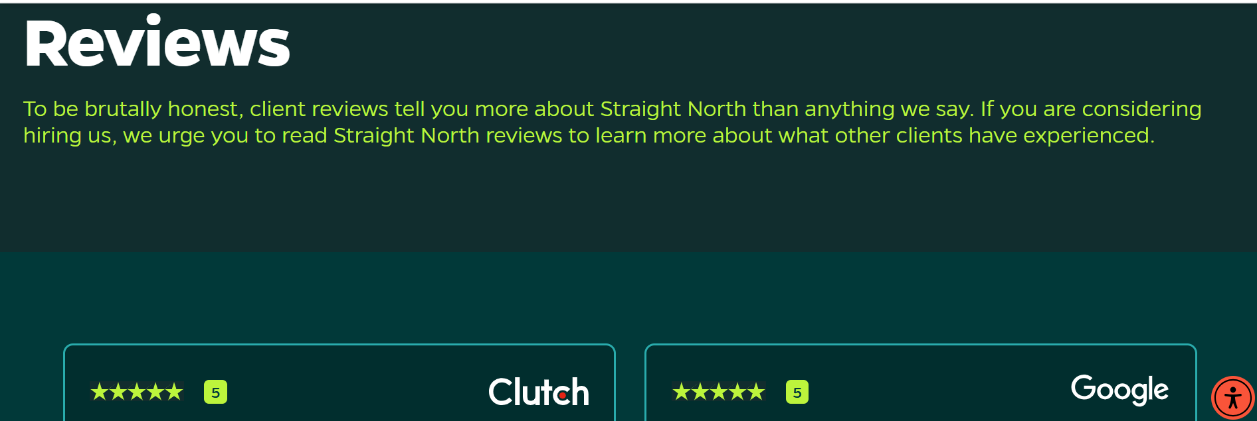

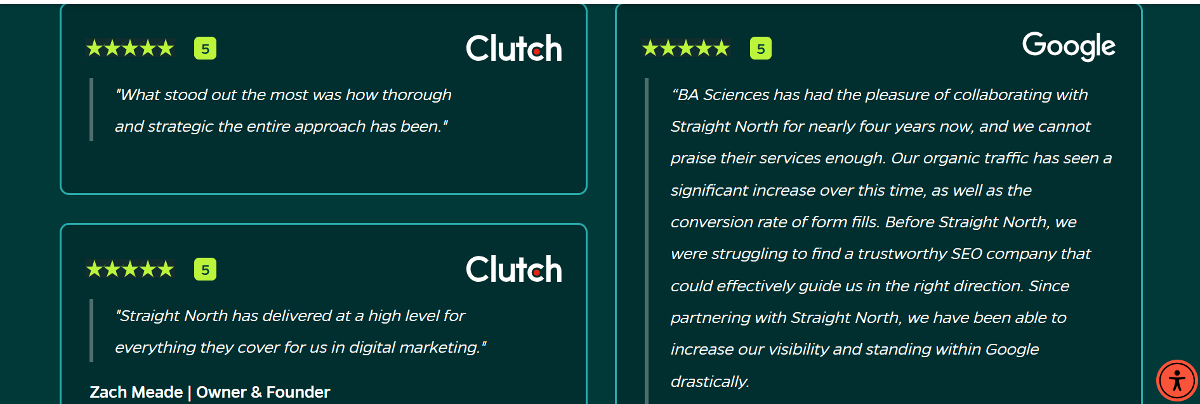

## Design & Color Palette (Consistency)

Since the screenshots in this document come from multiple sources, they use different colors. For the final website design, we will unify everything under one consistent color palette. This ensures a professional and cohesive brand look.  
  
Recommended Palette:  
- Primary Color: Blue (#1E3A8A) → represents trust and professionalism.  
- Accent Color: Orange (#F97316) → for CTAs like 'Contact Us' or 'Get a Quote'.  
- Neutral Colors: Gray (#6B7280) and White (#FFFFFF) → for backgrounds and text.  
  
Alternative Options:  
- Green + Dark Gray → growth and stability.  
- Purple + Teal → creativity and innovation.

# Workflow: Building a Digital Marketing Website with Python (Django)

This workflow explains how a digital marketing website can be developed using Python and Django. It covers the process from environment setup to deployment, ensuring that the website is structured, functional, and visually aligned with the chosen design palette. Each step focuses on a key milestone such as creating apps, defining models, building templates, adding functionality, and deploying the final product with consistent branding. This provides a clear roadmap for taking the project from idea to implementation.

## Steps

- Setup Environment – Install Python, create virtual environment, install Django and libraries.

- Start Project & Apps – Create Django project and apps (CMS, Portfolio, Leads).

- Database & Models – Define models for Services, Case Studies, Leads, Team Members, Testimonials.

- Admin Panel Setup – Register models in Admin to easily manage content.

- Frontend & Templates – Build HTML templates and apply Bootstrap/Tailwind. Add color palette in CSS.

- Functionality – Homepage fetches data dynamically, contact form stores leads, case studies show results.

- Testing – Check navigation, forms, responsiveness across devices.

- Deployment – Deploy on cloud (Heroku, Render, AWS), configure static files, add SSL.

- Final Touches – Apply consistent color palette, branding, and integrate analytics/SEO.